**CSC 18B Quiz #3 (25 pts) – May 3rd, 2016** **Name : . .Mauricio S. Perez .**

All answers must be of your own work. Type out your answers and submit your quiz through Blackboard for Quiz #2 as either a MS Word document or PDF file (Mac users using Pages, make sure to Export to MS Word).

1. Two tasks that are operating ***concurrently*** are both making progress at once. (4points )
   1. concurrently

1. Two tasks that are operating ***in parallel*** are executing simultaneously. ( 4 points )
   1. in parallel
2. Name all of the states that are in a thread’s life cycle. ( 5 points )

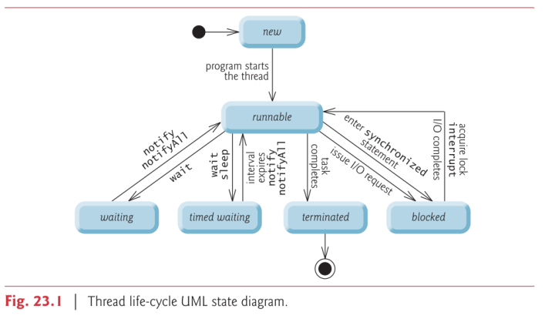

***1. New and Runnable States***

***2. Waiting State***

***3. Timed Waiting State***

***4. Blocked State***

***5. Terminated State***

*Section 23.2 in Early Objects Book*

1. A new thread begins its life cycle by transitioning to the ***new*** state. ( 4 points )

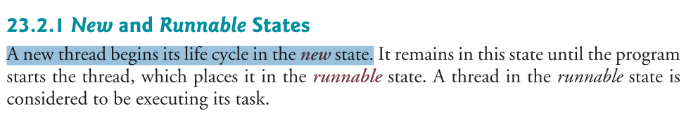

* 1. new.

1. A waiting thread transitions back to the ***runnable*** state only when another thread notifies it to continue executing.

( 4 points )

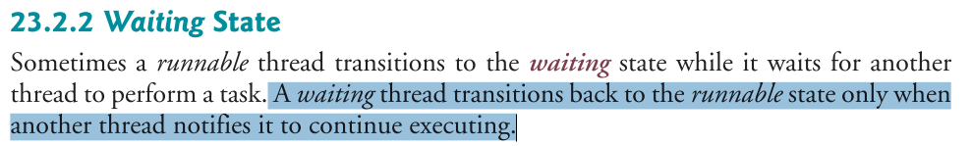

* 1. runnable